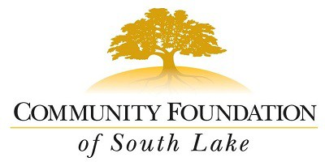
2016-2017 GRANT APPLICATION

Thank you for your interest in applying for a non-profit investment from the Community Foundation of South Lake. We are so proud to serve the community of South Lake County. Applications are due by January 31st at 12pm, no exceptions. Award notifications will be made in March 2017.

Community Grants:
- Are awarded up to $10,000.
- Are awarded twice per year.
- Must be used within the 1 year time
frame outlined in the award agreement. Any expenditure changes must be approved, in writing, by CFSLC prior to implementation by the grantee.
- Are awarded to non-profits who have
specific program or capacity needs.
- Indirect costs cannot exceed 20% of the ask.

Applicants are required to:
  - Be an active 501(c)(3).
  - Complete an application in its entirety.
  - Provide all attachments requested as applicable.
  - Use the funds requested to serve South Lake County (includes Clermont, Ferndale, Groveland, Mascotte, Minneola, Stuckey, and Montverde). Please note that this does not exclude organizations that are outside of the geographical area but the grant investment must directly serve South Lake County residents.
  - Have a minimum of one year of financial data (refer to page 4 of the application)
  - Submit application and attachments via Drop Box on-line.

Ineligible Applicants:
- Cities and municipalities. However, the Foundation will invest in projects where non-profits partner with cities.
- Direct support for organizations such as band boosters or parent associations that support public schools, unless they are a registered 501(c)(3).
- Organizations who have not been established and running as a 501(c)(3) for 1 year or more.
- Endowments
- Capital Campaigns
- Fundraising expenses, sponsorship, or thrift stores
- Lobbying, activism, or litigation
- No support for religious organizations for religious purposes

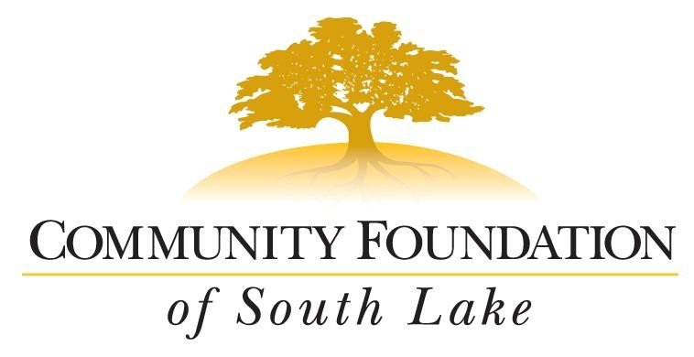
Community Foundation of South Lake
GRANT APPLICATION FORM
2150 Oakley Seaver Drive, Clermont, FL 34711
Ph: 352.394.3818

ORGANIZATION SUMMARY

Name of Organization:
Name of CEO/ED: Email: ___________________________________________
Mailing Address: City: State: Zip: Phone: Mobile: Fax: Website: _________
Tax ID Number (FEIN): Year Founded:
Do you use the EIN/Tax ID of a national or other organization with which you are affiliated? Yes No
If yes, please provide the name of the national/other organization: Is your organization an IRS 501(c)(3) not-for-profit in good standing? Yes No

CONTACT INFORMATION

Name of Contact Person for Application:
Contact phone: ( ) Contact email:

PROGRAM

Proposed Grant Use: Program equipment/infrastructure Other

Project Dates: Start
End
*start must be after grants are awarded

MM/DD/YY MM/DD/YY

What is the organization's mission?

What is the geographical area served by the organization?

What geographical area will the requested funds impact?

Describe the program, population served and how the specific requested funds will be used. (Be very specific, 800 words or less)

Describe the impact that the organization has made in the past. Describe the impact that program specific to the funding request has made in the past OR evidence supporting that this program is beneficial to or is of need in the community.

How will the impact of this program be measured? (what "tools" will be used, etc.)

How is your organization currently involved in South Lake County?

How will the program continue beyond the grant period?

List the names of other organizations/agencies with which your organization is collaborating on this project and how will the other organizations be involved? (200 words or less; not required.

FINANCIAL INFORMATION

Total Organizational Budget: $ __________________

Total Budget for Proposed Program: $ ________________

Amount being requested from CFSLC: $

Has this program been previously funded by CFSLC? Yes No

If yes, what was the project year? _____________

What are other secured or pending funding sources for this program? (source name and amount)

If CFSLC awards partial funding, how will partial funding impact the program?

ATTACHMENTS

Please include the following forms when uploading this application into Dropbox online. (Use this page as a check off list for your uploads!)

  - Proof of 501(c)(3) determination letter
  - CFSLC Budget Form of the organization's annual budget
  - CFSLC Budget Form of your Program Budget (specific to funding being requested)
  - Most recent 990
  - Copy of most recent audit (if applicable)
  - List of Board of Directors & their affiliations
  - This completed application

SIGNATURE

Applicant Certification:
All information contained in the application is verified to be true and correct to the best of my knowledge. The governing body of the applicant has duly authorized this grant request. The applicant agrees to report to the Foundation on the use of any grant funds received and on the progress of the project to be funded; the applicant will comply with applicable laws, regulations, terms and conditions in effect at the time of grant award. I further understand that the Community Foundation Of South Lake, in evaluating the grant application may review any information submitted as part of this request with advisors of the Foundation’s choosing and will treat information submitted by the applicant in a confidential manner. It is understood that submission of this application does not guarantee funding.

Name of CEO/Executive Director (printed): Title:

Signature:
Date:

Name of Board Chair/Officer (printed):
Title:

Signature: Date:

